Problem1
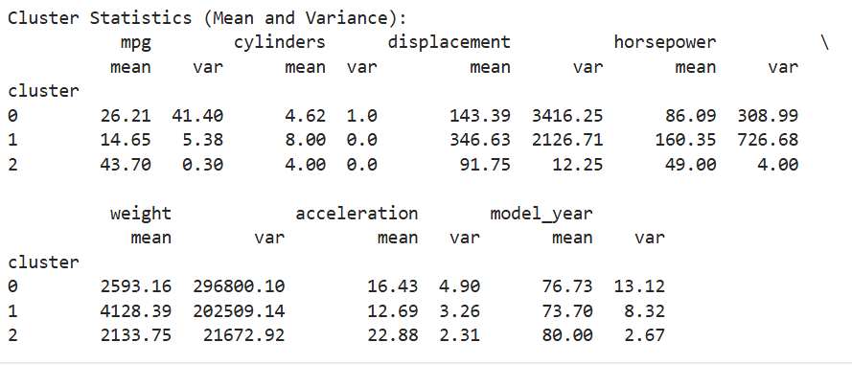
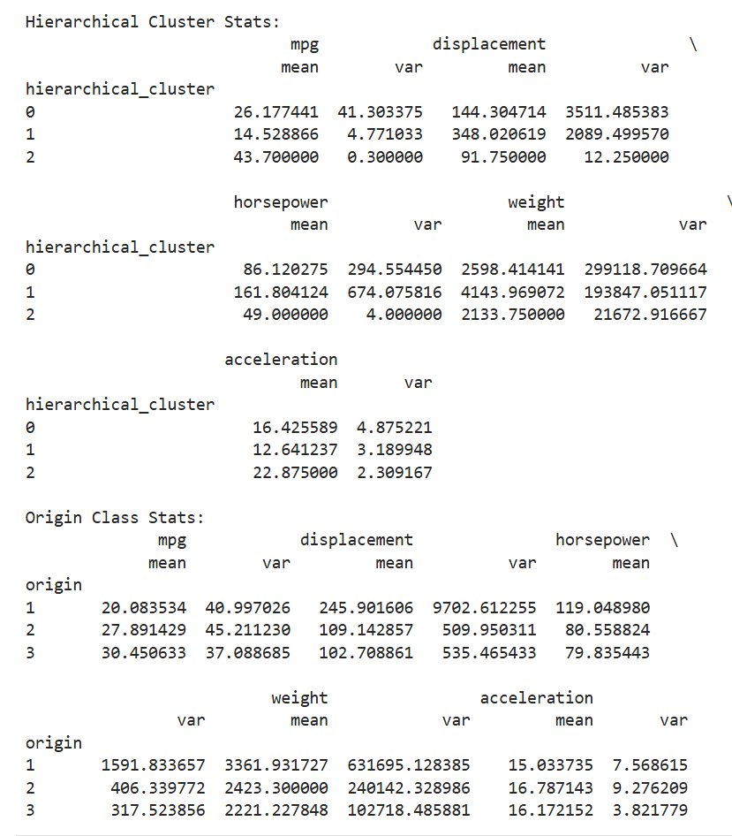
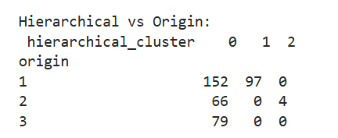

Analysis：
Cluster 0: mpg=26.21, displacement=143.39, horsepower=86.09 is close to the mid-size car characteristics of origin=2 (mpg=27.89, displacement=109.14) and origin=3 (mpg=30.45, displacement=102.71) but contains 152 origin=1 vehicles reflecting the overlap of cross-origin mid-size car characteristics. ) small and medium vehicle characteristics, but contains 152 origin=1 vehicles, reflecting the overlap of small vehicle characteristics across origins.
Cluster 1: mpg=14.65, displacement=346.63, horsepower=160.35 is highly consistent with origin=1 (mpg=20.08, displacement=245.90, horsepower=119.05), reflecting the large, high-powered character of the American vehicles.
Cluster 2: mpg=43.70, displacement=91.75, horsepower=49.00, far exceeds origin=2's mpg=27.89 and displacement=109.14, capturing a subset of European cars that are extreme high gas mileage small cars.

Relationship between clusters and origin:
Cluster 0: contains 152 American (origin=1), 66 European (origin=2), 79 Japanese (origin=3), highly mixed, no clear correspondence, reflecting the commonality of origin of small and medium-sized car features.
Cluster 1: only contains 97 American cars (origin=1), with features matching American large cars and clear relationships.
Cluster 2: only 4 European cars (origin=2), features reflecting small cars with high fuel consumption, clear relationship but small sample size.

Answer：
Cluster 1 has a strong and clear relationship with origin=1, Cluster 2 has a clear but restricted relationship with origin=2 (small sample size), Cluster 0 has no clear correspondence, and the overall relationship is not entirely clear.

Problem2
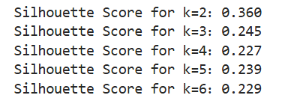
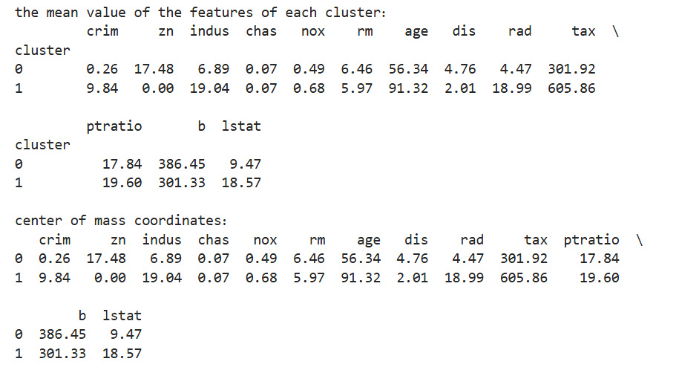

Optimal Clustering:
Based on the Silhouette Score, ( k=2 ) is the optimal clustering (Silhouette Score=0.360).
Cluster 0 represents high-quality suburbs (low crime, high room count, low low-income population) and Cluster 1 represents low-quality industrial areas (high crime, low room count, high low-income population).

Cluster Feature Mean:
Provided, accurately reflecting ( k=2 ) cluster characteristics (see table above).

Mean and center of mass differences:
No differences, each cluster has exactly the same feature mean and center of mass coordinates (all features are accurate to two decimals).

Problem3
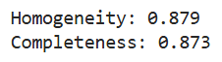

Analysis:
Homogeneity (0.879):
Scores close to 1 indicate that each cluster is highly “pure”, i.e., the samples in each cluster mainly belong to a single class (e.g., cluster 0 contains mainly samples from class 0).
This indicates that K-Means clustering has very little confusion in class labeling within clusters when distinguishing between wine types, and only a few samples may have been misassigned.
Completeness (0.873):
The score is also close to 1, indicating that samples of the same class (e.g., all samples of class 0) are mostly assigned to the same cluster without significant dispersion.
This indicates that the K-Means clustering successfully clustered the samples of each wine type together and that the completeness of the classes was well maintained.

Meaning of Homogeneity and Completeness Indicators

Homogeneity:
Definition: A measure of whether each cluster contains only samples of a single class of labels. The score ranges from [0, 1], with 1 indicating that each cluster is completely “pure” (contains only one class).
Formula: $h=1- H(C) /H(C∣K) ​$
where 𝐻(𝐶)is the entropy of the class labeling, and 𝐻(𝐶∣𝐾)is the conditional entropy of the class labeling after a given cluster assignment.
information provided:
Reflects the “purity” of the clusters, i.e., the homogeneity of the class labels of the samples within the clusters.
High homogeneity indicates that each cluster represents mainly one wine type, with very few mixed samples within the cluster.
Limitations: does not care if samples of the same class are dispersed across multiple clusters. For example, the samples of class 0 may be split into two “pure” clusters, and homogeneity is still high.

Completeness:
Definition: a measure of whether all samples of the same class are assigned to the same cluster. Scores range from [0, 1], with 1 indicating that the samples from each class are completely clustered in a single cluster.
Formula: $c=1-H\left(K\right)/H\left(K ∣ C\right)​$
where 𝐻(𝐾) is the entropy of the cluster assignment, and 𝐻(𝐾∣𝐶)is the conditional entropy of cluster assignment given the class labeling.
Information provided:
Reflects the “clustering” of samples of the same class, i.e., whether samples of the class are dispersed into multiple clusters.
High completeness indicates that the samples of each wine type are mostly concentrated in a single cluster and are not partitioned.
Limitations: does not care if samples from other classes are mixed within the cluster. For example, a cluster may contain samples of class 0 and class 1, but the samples of class 0 are all clustered there and completeness is still high.

Conclusion:
Both homogeneity (0.879) and completeness (0.873) are high, indicating that K-Means clustering (k = 3) effectively captured the 3 types of wine dataset, with cluster assignments highly aligned with actual class labels.
Scores slightly below 1 may be due to misallocation of a small number of samples, possibly due to feature overlap or randomness of the K-Means algorithm.

